**CAR AUTOMATION and OBSTACLE AVOIDANCE**

A SUMMER TRAINING PROJECT REPORT

**Submitted by**

PRIYA GUPTA, JAHNVI TYAGI

Under the guidance of

Dr. SRN Reddy, Associate Professor, IGDTUW

***in partial fulfilment for the award of the certificate***

***in***

**“Build Your Smart Device”**

**Organizing by CSE Department, Indira Gandhi Delhi Technical University For Women, Delhi in collaboration**

**with Microsoft Finland**

(From 5-06-2017 to 14-07-2017)

**CERTIFICATE**

This is to certify that Summer Training Project Report entitled “**Car** **Automation**” submitted by **Priya Gupta** and **Jahnvi Tyagi** is an authentic work carried out by them at Indira Gandhi Delhi Technical University for Women, Delhi under my guidance during STP8 in 2017. The matter embodied in this project work has not been submitted earlier for the award of any degree or diploma to the best of my knowledge and belief.

Date:

Signature of the Guide:

Signature of students:  **Dr. S.R.N Reddy**

**Associate Professor,**

**Kashmere Gate, Delhi**

**ACKNOWLEDGEMENT**

We have taken efforts in this project. However, it would not have been possible without the kind support and help of many individuals and organizations. I would like to extend my sincere thanks to all of them.

I am highly indebted to Dr S.R.N Reddy for his guidance and constant supervision as well as for providing necessary information regarding the project & also for his support in completing the project.

I would like to express my gratitude towards my parents & members of IGDTUW for their kind co-operation and encouragement which help me in completion of this project.

I would like to express my special gratitude and thanks to industry persons for giving me such attention and time.

My thanks and appreciations also go to my colleague in developing the project and people who have willingly helped me out with their abilities.

**Priya Gupta, Jahnvi Tyagi**

**B.Tech, CSE,IGDTUW**

**ABSTRACT**

On noticing the increasing number of car accident cases in these days, our project aims at reducing the same by interfacing an ultrasonic sensor which detects the distance of the obstacle from the car and changes it direction or stops it accordingly. Also, it solves the problem of misplacement of keys by providing a key less entry as the car is controlled with an app that can be installed on an android mobile phone. The car driver is not needed to be seated at a particular position in the car as it can be operated by the car controls given in the app, sitting anywhere inside it.

**List of Publications**

* Android Programming: The Big Nerd Ranch Guide (Big Nerd Ranch Guides)

(By: Bill Philips & Brian Hardy )

* Android Design Patterns: Interaction Design Solutions for Developers

(By: Greg Nudelman )

* Android User Interface Design: Turning Ideas and Sketches into Beautifully Designed Apps

(By: Ian G. Clifton )

* Android Recipes: A Problem-Solution Approach

(By: Dave Smith & Jeff Friesen )

* Hello, Android: Introducing Google's Mobile Development Platform (Pragmatic Programmers)

(By: Ed Burnette )

* Beginning Android Games

(By: Mario Zechner )

**CONTENTS**

|  |  |
| --- | --- |
| **Certificate** |  |
| **Acknowledgement** |  |
| **Abstract**  **Introduction**  **Components**   1. **Hardware** 2. **Software**   **Working Principle**  **Flowchart**  **Block Diagram**  **Applications**  **Future scope**  **Advantages and Limitations**  **Conclusion**  **References** |  |
|  |  |
|  |  |
|  |  |

|  |  |  |
| --- | --- | --- |
|  |  |  |

**INTRODUCTION**

## Generic Remote Monitoring and Control System

Most of the domestic and industrial systems are leading towards automation these days. The most important property of a automated system is to remotely monitor and control the applications that are interfaced with the system. This functionality enables the user to transmit and receive the data to and from the system, examine and analyze it. Remote Monitoring and control systems consists of three major blocks

1. Remote Monitoring Station
2. Central control Station and
3. Communication module

**Remote Monitoring Station**- It consists of a communicating device which can send control instructions to the central control station through the communication network and also monitors and checks the data returned by the control station, compares this data with a stored set of data and sends instructions accordingly via the communication link if any abnormal condition occurs. It also allows for the switching of devices, raising alarms etc. based on information received from the central control station.

**Central Control Station**- The central control station receives the instructions from the remote monitoring station and accordingly sends the switching instructions to the appliances interfaced with it. It also sends the monitoring information to the remote monitoring station so that control actions should be taken by it.

**Communication Module-** All these control instructions and monitoring data are transmitted and received via this communication module. There are several technologies used for the communication between the remote monitoring station and central control station. These are internet, RF (Radio Frequency), Bluetooth, GSM and GPRS. These technologies are explained in the following chapters.

The basic block diagram of this remote control and monitoring System is given in figure 1.1.

**Remote**

**Monitoring Station**

**Communication Module**

**Central Control Station**

**PROJECT BACKGROUND**

In today’s times, there are increasing no of cases of car accidents and theft, often due to misplacement of keys. Our project aims to provide an easy and cost efficient solution to these problems.

* The car can be controlled using an app installed in the owner’s Android phone, thus enabling the driver to sit anywhere in the car as steering wheels would not be required and the car could be controlled using simple commands.
* It prevents accidents by changing directions or stopping the car when the obstacle comes too close.
* In cases of accidents (collision), a call is automatically made to he emergency number as specified by the user.
* Due to an increase in number of accidents at night ,we have added LEDs that start glowing as soon as it gets dark.

**VEHICLE COMPONENTS**

1. *HARDWARE*

* *Bluetooth*
* *8051 Microcontroller*
* *Ultrasonic sensor*
* *Battery*
* *GSM module*
* *Motor driver*
* *DC motors*
* *lED*
* *LDR sensor*

1. *Software*

* *Kiel vision*
* *Nuvoton*
* *MIT app inventor*

1. **Bluetooth**

HC-05 module is an easy to use Bluetooth SPP (Serial Port Protocol) module, designed for transparent wireless serial connection setup.

Serial port Bluetooth module is fully qualified Bluetooth V2.0+EDR (Enhanced Data Rate) 3Mbps Modulation with complete 2.4GHz radio transceiver and baseband. It uses CSR Bluecore 04-External single chip Bluetooth system with CMOS technology and with AFH(Adaptive Frequency Hopping Feature). It has the footprint as small as 12.7mmx27mm. Hope it will simplify your overall design/development cycle.

Specifications :

**Hardware Features**

* Typical -80dBm sensitivity
* Up to +4dBm RF transmit power
* Low Power 1.8V Operation ,1.8 to 3.6V I/O
* PIO control
* UART interface with programmable baud rate
* With integrated antenna
* With edge connector

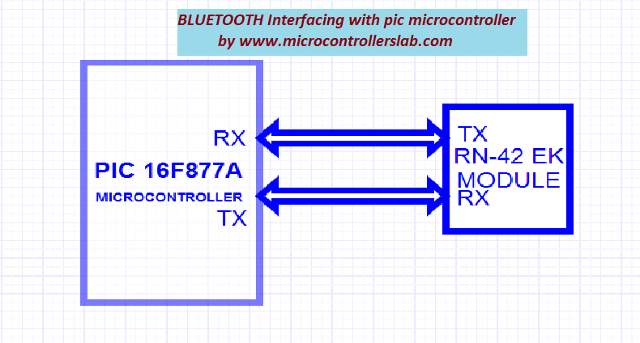

**Software Features**

* Default Baud rate: 38400, Data bits:8, Stop bit:1,Parity:No parity, Data control: has.
* Supported baud rate: 9600,19200,38400,57600,115200,230400,460800.
* Given a rising pulse in PIO0, device will be disconnected.
* Status instruction port PIO1: low-disconnected, high-connected;
* PIO10 and PIO11 can be connected to red and blue led separately. When master and slave
* are paired, red and blue led blinks 1time/2s in interval, while disconnected only blue led blinks 2times/s.
* Auto-connect to the last device on power as default.
* Permit pairing device to connect as default.
* Auto-pairing PINCODE:”0000” as default
* Auto-reconnect in 30 min when disconnected as a result of beyond the range of connection.

1. **8051 Microcontroller**

The Intel 8051 is an 8-bit microcontroller which means that most available operations are limited to 8 bits. There are 3 basic "sizes" of the 8051: Short, Standard, and Extended. The Short and Standard chips are often available in DIP (dual in-line package) form, but the Extended 8051 models often have a different form factor, and are not "drop-in compatible". All these things are called 8051 because they can all be programmed using 8051 assembly language, and they all share certain features (although the different models all have their own special features).

Some of the features that have made the 8051 popular are:

* 4 KB on chip program memory.
* 128 bytes on chip data memory(RAM)
  + 32 bytes devoted to register banks
  + 16 bytes of bit-addressable memory
  + 80 bytes of general-purpose memory
* 4 reg banks.
* 128 user defined software flags.
* 8-bit data bus
* 16-bit address bus
* 16 bit timers (usually 2, but may have more, or less).
* 3 internal and 2 external interrupts.
* Bit as well as byte addressable RAM area of 16 bytes.
* Four 8-bit ports, (short models have two 8-bit ports).
* 16-bit program counter and data pointer.
* 1 Microsecond instruction cycle with 12 MHz Crystal.

Variants of the 8051 may also have a number of special, model-specific features, such as UART, ADC, Op_Amps, etc., making it an even more powerful microcontroller.

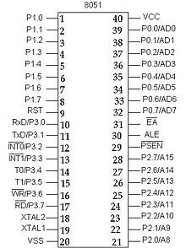

1. **Ultrasonic sensor**

The ultrasonic sensor is used for obstacle detection. Ultrasonic sensor transmits the ultrasonic waves from its sensor head and again receives the ultrasonic waves reflected from an object.

There are many applications use ultrasonic sensors like instruction alarm systems, automatic door openers etc. The ultrasonic sensor is very compact and has a very high performance.

[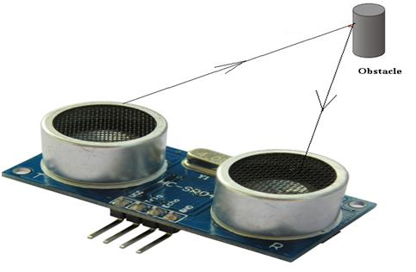](https://www.elprocus.com/wp-content/uploads/2013/09/Ultrasonic-Sensor-General-Diagram.jpg)

The ultrasonic sensor emits the short and high frequency signal. These propagate in the air at the velocity of sound. If they hit any object, then they reflect back echo signal to the sensor. The ultrasonic sensor consists of a multi vibrator, fixed to the base. The multi vibrator is combination of a resonator and vibrator. The resonator delivers ultrasonic wave generated by the vibration.  The ultrasonic sensor actually consists of two parts; the emitter which produces a 40 kHz sound wave and detector detects 40 kHz sound wave and sends electrical signal back to the microcontroller.

**Applications of Ultrasonic Sensor:**

* Automatic change over’s of traffic signals
* Intruder alarm system
* Counting instruments access switches parking meters
* Back sonar of automobiles

**Features of Ultrasonic Sensor:**

* Compact and light weight
* High sensitivity and high pressure
* High reliability
* Power consumption of 20mA
* Pulse in/out communication
* Narrow acceptance angle
* Provides exact, non-contact separation estimations within 2cm to 3m
* The explosion point LED shows estimations in advancement

1. **GSM module**

The main principle of this circuit is to interface a GSM modem with the microcontroller. The microcontroller used is AT89C51 microcontroller. To communicate with GSM modem, AT commands are required. Microcontroller sends these commands to the GSM modem, which is then activated to perform the required operation.

The following AT commands are frequently used to control the operations of GSM modem.

**Command –  Operation**

* AT+CSMS    –    Select message service.
* AT+CMGF   –    Message format.
* AT+CMGL   –    List messages.
* AT+CMGR   –    Read message.
* AT+CMGS   –    Send message.
* AT+CMGD   –   Delete message.
* ATA              –    Answer a call.
* ATD              –   Dial a number.
* ATDL            –  Dial the last outgoing number.
* ATH             –   Hang up the call.

**Mobile**

**Laptop**

**GSM modem**

**Microcontroller**

**Applications**

**Bluetooth modem**

1. **LED**

Thus, LED is directly connected to the AT89C51 microcontroller. The negative terminal of the LED is connected to the ground through a resistor. Generally, microcontrollers output a maximum voltage of 5V. Thus the value of resistor calculated for this is 330 Ohms. Thus this can be connected either to the cathode or anode of the LED.

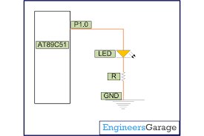

1. **LDR sensor**

A Light Dependent Resistor (LDR) or a photo resistor is a device whose resistivity is a function of the incident electromagnetic radiation. Hence, they are light sensitive devices. They are also called as photo conductors, photo conductive cells or simply photocells.

**Working principle:**

**It works on the principle of photo conductivity.**

Photo conductivity is an optical phenomenon in which the materials conductivity is increased when light is absorbed by the material.  
When light falls i.e. when the photons fall on the device, the electrons in the valence band of the semiconductor material are excited to the conduction band. These photons in the incident light should have energy greater than the band gap of the semiconductor material to make the electrons jump from the valence band to the conduction band. Hence when light having enough energy strikes on the device, more and more electrons are excited to the conduction band which results in large number of charge carriers. The result of this process is more and more current starts flowing through the device when the circuit is closed and hence it is said that the resistance of the device has been decreased. This is the most common **working principle of LDR**

**Applications of LDR:**

* Alarm locks
* Street light
* Light intensity meters
* Burglar alarm circuits

**Various manufacturers:**

Following are the other popular LDR manufacturers:  
• EXCELITAS TECH   
• ADVANCED PHOTONIX   
• LPRS   
• Cosmic Devices

1. **Kiel Vision**

µVision is a sophisticated IDE and Debugger/Simulator that offers numerous benefits to serious ARM embedded developers.

1. View the [µVision IDE Benefits](http://www.keil.com/arm/idebenefits.asp).

The µVision Debugger allows you to test programs with the integrated simulator or with the Keil ULINK USB-JTAG Adapter. Simulation allows software testing without hardware and provides fast edit-compile-test cycles, improves product quality, and enables reproducible regression test results.

The benefits of combining simulation and JTAG debugging are summarized in the following table.

|  |  |  |  |
| --- | --- | --- | --- |
| Feature | Simulator | JTAG Debugger | Description |
| **Breakpoints** | **Unlimited Breakpoint Capabilities** including access, conditional, and execution breakpoints. | **Embedded ICE Restrictions**include only two execution/access breakpoints in Flash. Unlimited software breakpoints in RAM. | Single-chip design has only Flash ROM for program code. |
| **Peripherals** | Simulated peripherals **fully synchronized** with program execution. | Peripherals **may not stop** when a breakpoint is triggered. | Simulation allows detailed analysis of complex algorithms that interface to peripherals. |
| **Power-Down and Idle Mode** | Power-down and idle modes are **fully simulated**. | Embedded ICE is **not available**in power-down or idle mode. | With simulation, it is possible to test situations that stop or even destroy real hardware. |
| **Trace and Timing Analysis** | **Full timing and execution analysis** with Code Coverage, Trace, Timing Profile, Logic Analyzer. | Extended test features **via ETM**, but impossible via JTAG. | ETM requires additional I/O pins which are not available on some devices. |
| **Input Signal Patterns** | Input signal generation **from a script language**; synchronized with program execution (single-stepping). | Input signals **provided by hardware** and external test equipment. | Simulation for verification of specifications; JTAG debugging for real-world testing. |
| **Real-Time Debugging** | Simulation is **timing accurate**and in correct relation to peripherals. | JTAG Debugging runs real-time **at full CPU speed**. | Simulation, while timing accurate, is 4-10 times slower than a high-speed ARM device. |

1. **Nuvoton**

Nuvoton's main product lines are Microcontroller Application IC, Audio Application IC, Cloud & Computing IC, and [foundry service](https://en.wikipedia.org/wiki/Foundry_model).[[1]](https://en.wikipedia.org/wiki/Nuvoton#cite_note-1) Its consumer electronics ICs focus mainly on [microcontroller](https://en.wikipedia.org/wiki/Microcontroller) ICs and voice and speech ICs. Its [ARM Cortex-M0](https://en.wikipedia.org/wiki/ARM_Cortex-M0)microcontroller IC NuMicro Family is well known for its density and functionality. Its computer IC product line designs and manufactures the key chips for PC motherboards, notebook computers and servers, offering complete Super I/O solutions, clock generators, hardware monitoring IC, power management IC, TPM security IC, [notebook keyboard controller](https://en.wikipedia.org/wiki/Laptop), and mobile platform [embedded controller](https://en.wikipedia.org/wiki/Embedded_controller) (EC).

Nuvoton operates a six-inch wafer fab which provides [foundry service](https://en.wikipedia.org/wiki/Foundry_model) for the company's own branded IC products, as well as for selected manufacturing partners.

**ARM**, originally **Acorn RISC Machine**, later **Advanced RISC Machine**, is a family of [reduced instruction set computing](https://en.wikipedia.org/wiki/Reduced_instruction_set_computing)(RISC) [architectures](https://en.wikipedia.org/wiki/Instruction_set) for [computer processors](https://en.wikipedia.org/wiki/Central_processing_unit), configured for various environments. British company [ARM Holdings](https://en.wikipedia.org/wiki/ARM_Holdings)develops the architecture and licenses it to other companies, who design their own products that implement one of those architectures‍—‌including [systems-on-chips](https://en.wikipedia.org/wiki/System_on_a_chip) (SoC) and [systems-on-modules](https://en.wikipedia.org/wiki/System_on_module) (SoM) that incorporate memory, interfaces, radios, etc. It also designs [cores](https://en.wikipedia.org/wiki/Semiconductor_intellectual_property_core) that implement this [instruction set](https://en.wikipedia.org/wiki/Instruction_set) and licenses these designs to a number of companies that incorporate those core designs into their own products.

1. **MIT App Inventor**

App Inventor lets you develop applications for Android phones using a web browser and either a connected phone or emulator. The App Inventor servers store your work and help you keep track of your projects.

You build apps by working with:

The *App Inventor Designer*, where you select the components for your app.

The *App Inventor Blocks Editor*, where you assemble program blocks that specify how the components should behave. You assemble programs visually, fitting pieces together like pieces of a puzzle.

Your app appears on the phone step-by-step as you add pieces to it, so you can test your work as you build. When you're done, you can package your app and produce a stand-alone application to install.

If you don't have an Android phone, you can build your apps using the *Android emulator*, software that runs on your computer and behaves just like the phone.

The App Inventor development environment is supported for Mac OS X, GNU/Linux, and Windows operating systems, and several popular Android phone models. Applications created with App Inventor can be installed on any Android phone.

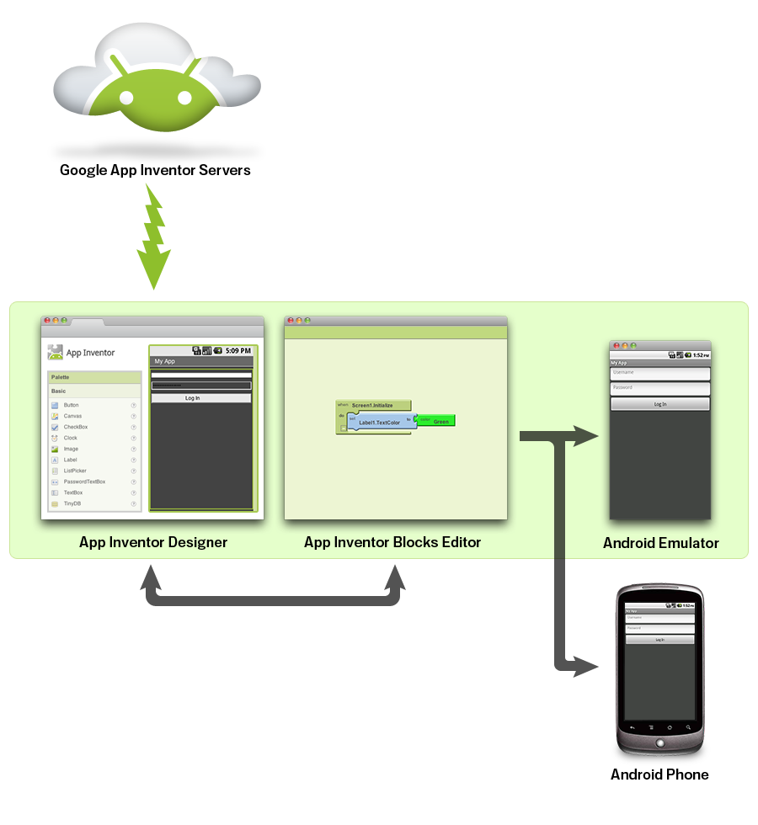

**WORKING PRINCIPLE:**

* 1. MOBILE APP DEVELOPMENT

A simple android app has been developed for the easy control of the vehicle. It uses simple commands : forward , back , right , left and stop. It uses Bluetooth communication to control the car.

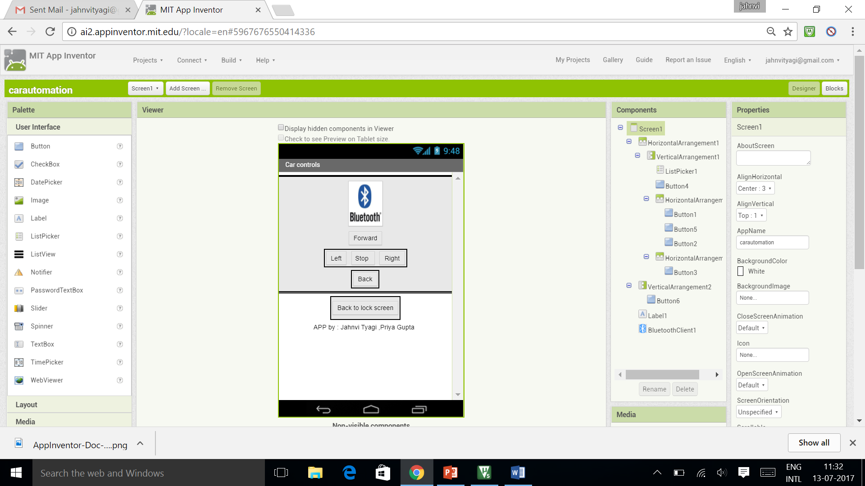

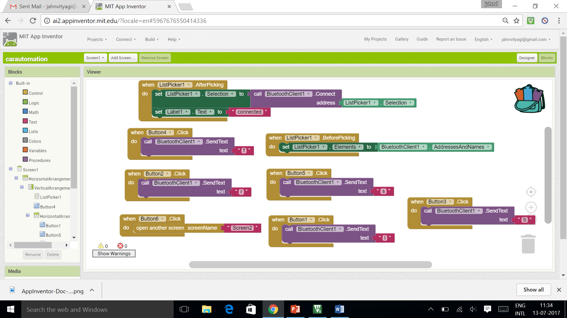

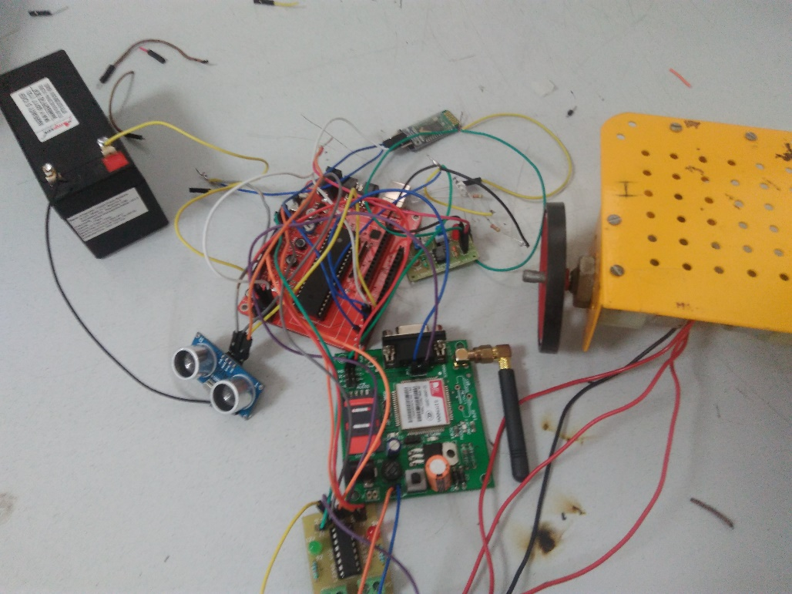

* 1. The model consists of an ultrasonic sensor whose trig is connected to P2^0 and echo to P3^2. As soon as the ultrasonic sensor detects an obstacle at distances specified in the source code, it turns the car left or stops it thus preventing accidents.

In case the obstacle is too close such that collision occurs, GSM module calls the emergency number given by the driver.

The LDR sensor gets activated as soon as it gets dark , helping the driver to have a clear view of the road ahead.

**FLOWCHART**

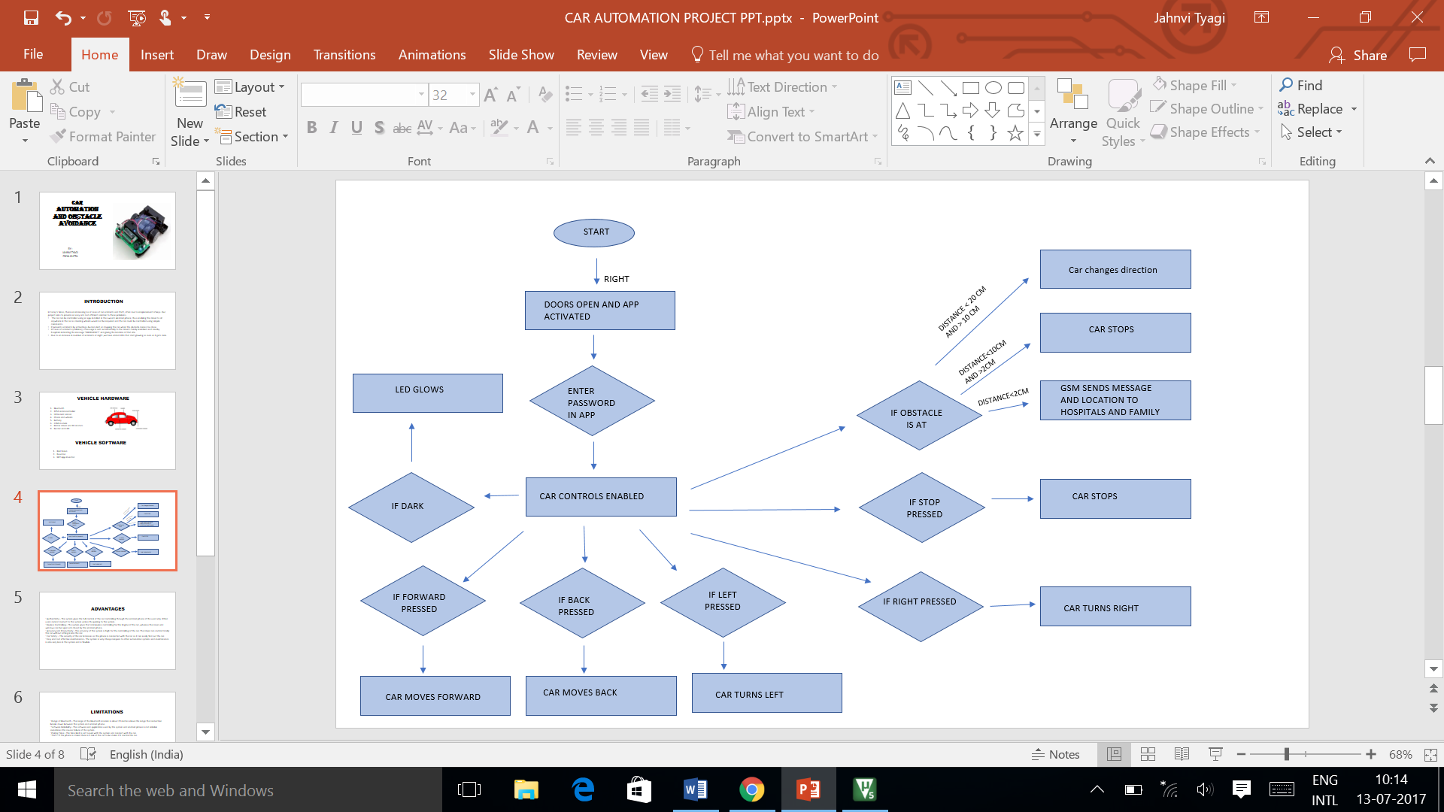

**BLOCK DIAGRAM**

MOBILE

MOTOR DRIVER

GSM MODULE

ULTRASONIC SENSOR

HEADLIGHTS

LDR SENSOR

APP

BLUETOOTH

MICROCONTROLLER

1. It has various military applications
2. It can be used for city wars
3. Obstacle avoiding robots can be used in almost all mobile robot navigation systems.
4. They can be used for household work like automatic vacuum cleaning.
5. They can also be used in dangerous environments, where human penetration could be fatal.

**APPLICATIONS**

**FUTURE SCOPE**

The following features can be further added in this project :

1. Use of GPS : In case of accidents a message “EMERGENCY“ can be sent to the drivers family members giving his exact location.
2. Use of camera using Raspberry Pi : Camera can be installed in the vehicle giving a better view of the road head. It would record the path in every 2 seconds for better decision making.
3. Automatic or Manual mode : The APP will allow the user to choose between automatic and manual mode. In automatic mode, the user will just have to enter the address of his destination and the vehicle will automatically follow the GPS directions to reach there. In the manual mode, the car control commands will open in the app.

**ADVANTAGES**

‘ Authenticity:- The system gives the full control of the car controlling through the android phone of the user only. Other users cannot connect to the system unless the pairing to the system.  
‘ Keyless Controlling:- The system gives the total keyless controlling for the Engine of the car ,whereas the doors and windows can be open and closed by the android phone.   
‘ Accuracy and Productivity:- The accuracy of the system is high for the controlling of the car. The driver can control totally the car without sitting inside the car.  
‘ Car Safety :- The security of the car increases as the phone is connected with the car so it can easily find out the car.  
‘ Easy and cost effective maintenance:- The system is very cheap compare to other automation systems and maintenance is also very less in the system and is flexible.

**LIMITATIONS**

‘ Range of Bluetooth:- The range of the Bluetooth modem is about 20 metres above the range the connection breaks down between the system and android phone.

‘ Software Reliability:- The software and application used by the system and android phone is not reliable sometimes this causes failure of the system.

‘ Pairing Time:- The time limit is set to pair with the system and connect with the car.

‘ Theft:- If the phone is stolen there is a risk of the car to be stolen if it control the car.

1. IEEE (2014 IEEE International Conference on Industrial Technology (ICIT), Feb. 26 - Mar. 1, 2014, Busan, Korea)Low Cost Smart Phone Controlled Car Security System by Hammad Afzal & Dr. Vrajesh D. Maheta
2. IEEE (2011 IEEE Control and System Graduate Research Colloquium) Mobile Phone Car Ignition System Using Embedded Blue 506 Bluetooth Technology by HarizHazli Bin Aziz, Noor Hafizah Abdul Aziz and Kama Azura Othman
3. IJCTEE (International Journal of Computer Technology and Electronics EngineeringVolume 3, Special Issue, March-April 2013, an ISO 9001: 2008 Certified Journal. E-NSPIRE, A National Level Conference held at Pravara Rural Engineering College, Loni, Maharashtra, INDIA.) Review of Various Functions Controlling Of Vehicle by Using Mobile Bluetooth by Dipak A. Mhaske, Prof. S.S. Katariya, Prof. S.S. Kadlag
4. . [Android Developers Guide. Android Architecture. [Online] 2013. URL: http://.android.com/about/versions/index.html.
5. Heidi Monson (1999) Bluetooth technology and implementations, John Wiley & Sons.
6. Piyare, R. and Tazil, M. (2011) “Bluetooth based home automation system using Android phones”. IEEE 15TH International symposium on consumer electronics (ISCE), 14-17 June 2011, Singapore.
7. . Potts, J. and Sukittanon, S. (2012) “Exploiting bluetooth on android mobile mobile devices for home security application”, proceedings of southeastcan, 15-18 March 2012, Orlando, Florida, USA.

**REFERENCES**